Shabbos Stories For
Parshas re’eh 5786
Volume 17, Issue 48 25 Menachem Av/August 8, 2026
Printed L’illuy nishmas Nechama bas R’ Noach, a”h
The Quiet Taxi Ride

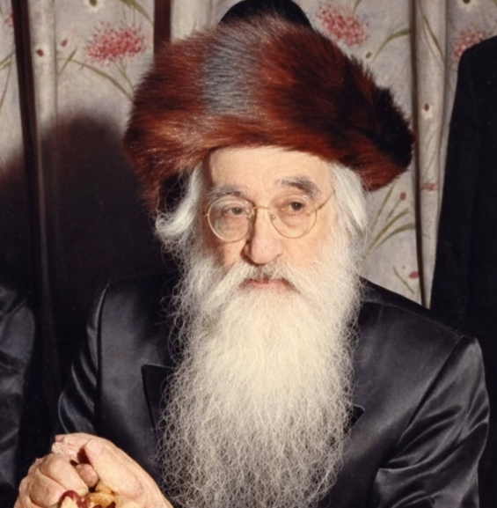

Rav Shlomo Mordechai of Boyan, zt”l, visited Eretz Yisroel in 1949. When he arrived, he arranged for a driver to take him from Tel Aviv to Haifa. When the taxi came, four Chasidim escorted him along the way, hoping that they would be able to spend some time talking to their Rebbe. They hoped to hear some of his insights and Divrei Torah. Perhaps he would share with them some stories about great Tzadikim.
But instead, the Rebbe stared out the taxi window the entire time. Not a word was spoken. In addition, when he arrived in Haifa, he did not get out of the taxi to visit anybody. He just asked the driver to take him back to his apartment in Tel Aviv. And just like the way there, he did not stop looking at the scenery the entire way back.
The Chasidim were completely confused by the trip. They could not understand why the Rebbe would have taken such a pointless ride. Finally, they arrived back home, and when they did, they asked their Rebbe why he had wasted over two hours of his day going on a leisure ride. What was he hoping to see?
The Rebbe smiled as he answered them. “The Pasuk says in Devarim (11:12), ‘Tamid Einei Hashem Elokecha Bah, the eyes of Hashem are always on Eretz Yisroel’. If Hashem is looking at the Land, then there must be something beautiful to see. That is why I was looking at it. I wanted to see what Hashem sees!”

Reprinted from the Parshas Pinchas 5786 email of Rabbi Yehuda Winzelberg’s Torah U’Tefilah.

Doing Something Extra for Hashem
by Yoni Schwartz

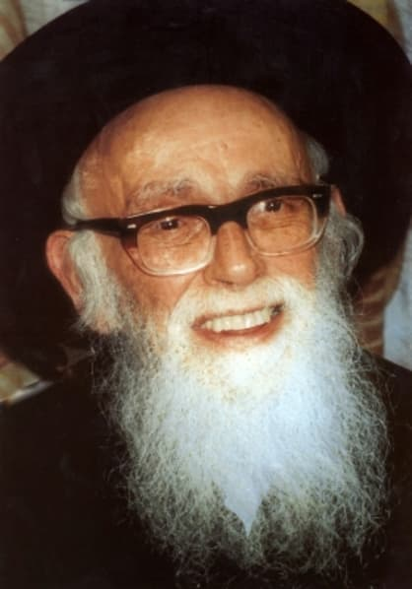

Years ago, a woman went around hospitals in Israel bringing joy to those who were struggling. She would organize delicious meals for the patients. Sometimes she would bring in other people, and other times she’d enter on her own, ready to do whatever the task called for, whether that was smiling and telling jokes or sitting there for hours listening to people pour their hearts out. She did, however, have one personal challenge that she wrestled with day in and day out. She and her husband were childless. She visited Rav Shlomo Zalman Auerbach, ZT”L, to discuss the matter. Expecting to hear sage words of wisdom and to be comforted, the Rav’s response surprised her.
“Hashem does not owe you anything,” he said. She was stunned. As she was processing his response, he continued, “However, if you do something extra for Hashem that you are not obligated to do, He will do something for you that He is not obligated to do.” She left with a newfound strength and commitment to work even harder on her chesed missions in the hospital. She began putting in more hours, more emotional energy, and sacrificing much of the comfort and leisure she previously enjoyed, helping those who were in pain. One year later, she had twins.

Reprinted from the Parshas Pinchas 5786 email of Torah Sweets.

Your Future Wife
Hasn’t Been Born Yet!

A young man who was having difficulty finding his Shidduch visited Rav Chaim
Kanievsky, zt”l, to seek his advice and Brachah. The man explained that he had
extended much effort, but he still could not find a suitable match, and asked for the Gadol’s guidance.
Rav Chaim asked him a few questions, and after thinking a little, responded that the young man’s Zivug (marriage partner) hadn’t been born yet, and wished him ‘Brachah V’Hatzlachah’, leaving the man in tears, despondent over the Rav’s words.
Two months had passed, and the young man returned to Rav Chaim Kanievsky with a smile on his face, and happily announced that he was a Choson! Those present were somewhat surprised, wondering how he was able to accomplish this in such a short amount of time, after hearing what the Rav had said.
The Choson explained that his Kallah was a Giyoress, a Jewish convert who had converted only a month earlier. “The Rav was correct,” he explained, “when he said my Zivug had not yet been born. Chazal teach us that a Jewish convert is like a newly born person. She had in reality not yet been born, since she was not yet part of the Jewish People!”
Reprinted from the Parshas Pinchas 5786 email of Rabbi Yehuda Winzelberg’s Torah U’Tefilah.
The Gift of Perceiving Reincarnation
From the Desk of Yerachmiel Tilles

Rabbi Aharon ‘the Great’, the first Karliner Rebbe, died young, in 1772 at age 36. Rabbi Shlomo, who was his closest disciple and destined to become his successor, did not want the position of Rebbe. Why not? Because R. Shlomo and R. Aharon had once been fellow students who sat together as equals at the house of their teacher, the Maggid of Mezritch. Therefore, it did not seem right to R. Shlomo now, that he should take his older comrade's place as Rebbe of Karlin.
Besides, R. Shlomo had seen how the people flocked to a Rebbe day and night, so that he had no privacy or peace. "I don't want such fame and responsibility," Shlomo said. "I just want to lead a private life as an ordinary Jew."

A Special Promise Made in a Dream
So, the Karliner Chasdim were left without a Rebbe. But then came the night when Rabbi Aharon himself appeared to R' Shlomo in a dream and said, "Shlomo, my friend and dearest student, if you will take on the yoke of leadership, you will be granted the power of seeing all the wanderings of souls in their various incarnations."
R. Shlomo could not resist the great temptation of this offer. To be able to read the past lives of all souls! Therefore, in the dream, he gave Rabbi Aharon his word that he would assume the succession and become the next Karliner Rebbe. As it was promised in the dream, so it became in the waking world.
That very same day, a messenger brought Reb Sholom a kvittel (lit. a note. i.e. a written prayer request), along with a great sum of money as a donation. The sender was a prosperous merchant, whom we shall call Mr. Geltman. He lay dying and wanted the Rebbe to make a miracle and save his life.
No sooner had Reb Shlomo read the kvittel from Mr. Geltman, then a second messenger arrived with another prayer request, this time from the woman who supervised the homeless shelter near the edge of town. She had come on behalf of a pregnant woman, whom we shall call Mrs. Bettler, who was staying at the shelter. Mrs. Bettler had been laboring in childbirth for several days, but was unable to deliver her child. The midwife could do nothing for her. Could the Rebbe help?
With his newly-acquired mystical insight, Reb Shlomo immediately saw that the soul of the dying Mr. Geltman was destined to be re-born into the body of Mrs. Bettler's unborn child. Alas, the poor child could not be born until the rich man had died! "So be it," sighed the new Rebbe. "May the will of G-d be done."
Within moments, word of the rich man's death and the beggar child's birth arrived, one upon the heels of the other. The next day, Reb Shlomo also heard that there was no firewood left at the homeless shelter, and the young mother and her newborn son were in danger of freezing to death. So, Reb Shlomo took some of the donation money that Mr. Geltman had sent and used it to buy more firewood. "It really is the boy's own money after all," he said to himself. "So, he deserves to benefit from it."

Gave the Money to Be Used for the Boy’s Care
Not long after that, he gave the rest of the money to Mrs. Bettler, to be used for the boy's care. When the boy and his mother were strong enough to travel, they went on their way with the other beggars, going from town to town. Six years later, the Bettlers happened to be passing through Karlin again. At the homeless shelter they heard that one of the sons of the deceased Mr. Geltman would be celebrating his own son's bar mitzvah.
As was the custom, the poor were all invited to the feast. So, Mrs. Bettler and her son went along with the others. As soon as they arrived at the Geltman house, the six-year-old boy's whole manner began to change completely. He took on an air of importance, and refused to sit at the pauper's table with the rest of the beggars. In a loud, arrogant voice, he demanded to be seated at the head of the guest table in a place of honor.
The child made such a great disturbance that Reb Shlomo stepped in and said, "Let's just humor the boy, so we can continue the celebration in peace." But the rabbi knew there was more to it, because he had recognized the boy as the reincarnated soul of Mr. Geltman "He is really the master of the house, and those are his sons," thought Reb Shlomo to himself. "All he is doing is asking for his due."

The Boy Refused to Take the Plain Foods
When the meal was served, the same thing happened; the Bettler boy refused to take the plain foods offered to the poor, and insisted upon getting the best cuts of meat and the choicest morsels from the head table. Once again, Reb Shlomo said, "Let him have his way, so he doesn't disturb the feast." But the other guests were getting upset with the boy. How dare he, a mere beggar's son, insult the Geltman brothers like that?
They asked his mother, "Does your son always behave like this?" "Why no," replied Mrs. Bettler, as puzzled as they were. "He's always been such a good boy, very quiet and well-mannered. He's never done anything like this before -- I just don't know what's gotten into that lad!"
At the end of the feast, after Reb Shlomo had already gone home, the Geltman brothers distributed money among the poor, as was the custom. When the Bettler boy's turn came, he looked disdainfully at the small coins and shouted, "How dare you offer me coppers!? Bring me gold from the treasure chest!"
By now, the Geltman brothers had had enough of his insolence, and Reb Shlomo was no longer there to intervene. So, the Geltmans told their servants to throw him out of the house. And they did. When Rabbi Shlomo later learned how the Geltman brothers had unknowingly mistreated their reincarnated father, he was deeply saddened. He could not bear the thought of spending his life watching such tragic scenes, so he begged Heaven to take away his miraculous powers. And they did.

Source: Excerpted, modified and supplemented by Yerachmiel Tilles from the Daily Zohar website. Why This Week? The 22nd day of the Jewish month of Tammuz [2026: July 6] is the yahrzeit of Rebbe Shlomo of Karlin.

Biographical notes: Rabbi Aharon the Great of Karlin (1736 - 19 Nissan 1772) was a disciple of Rabbi Dov-Ber of Mezritch. He was the pioneer of chasidism in Lithuania, as is evidenced by the fact that in contemporary sources, "Karliner" became a local synonym for "chasid". He is remembered for the ecstatic and unrestrained fervor of his prayer, for his solicitude for the needy, and for the moral teachings embodied in his Azharos ("Warnings").
He was succeeded by his colleague and disciple R. Shlomo of Karlin, after whose death the succession reverted to R. Aharon's son, R. Asher of Stolin (d. 1823). The dynasty still thrives today, and the chasidim of Karlin and of Stolin are known for the volume of their communal prayers. Rabbi Shlomo of Karlin [1738 - 22 Tammuz 1792], was a student of the Maggid of Mezritch and Rabbi Aharon the Great of Karlin, whom he succeeded in 1772.
R' Shlomo was well known for the extraordinary fervor and enthusiasm with which he prayed and studied. Most of the chasidic leaders of the next generation in the Lithuanian region were his disciples, including Rabbi Uri of Strelisk, known as the Saraf (‘burning angel’) and Rabbi Asher, the first rebbe of Stolin. 1 He died Al Kiddush HaShem, a holy martyr, stabbed by a Cossack with a sword while in the midst of the Amida prayer. The tzadik, Rabbi Yisrael of Rozhin, said about Rabbi Shlomo of Karlin that he was Mashiach ben Yosef and therefore he died.

Reprinted from the Parshat Mattot-Masei 5786 email of KabbalaOnline.org, a project of Safed of Ascent in Israel.

An Inspiring Stcory of
Rav Shimon Sofer
By Yehuda Z Klitnick

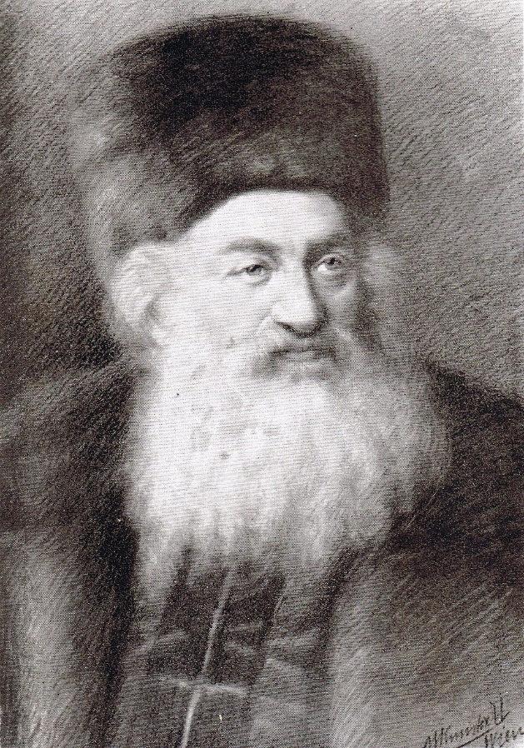
Rav Shimon Sofer, zt”l

A Jewish family living in Russia, had a young daughter, about ten years old, when one day, she simply ceased to utter a sound. At first, the parents thought it was a passing phase. They tried to coax her to speak, showering her with affection and encouragement, promising her gifts and sweets, but she continued her silence.
This gave her parents no rest. What didn't they do for her? They took her to the best doctors, sat her before consultants and specialists, but no one had a solution to the mystery: how a healthy, whole girl, who until recently conversed and spoke like any other child, suddenly became mute overnight. No one had a way to diagnose the strange affliction or understand what she was experiencing. The pain and suffering of the daughter merged with the pain and suffering of the parents, who cried out and wept, but there was no savior.
After days and weeks passed with no salvation in sight, a single spark of hope glimmered in the darkness. The parents heard that in the city of Kraków, Poland, resided Rabbi Shimon Sofer, author of Michtav Sofer. He was the oldest son of the Chasam Sofer, who mirrored his father's greatness. Through the power of his Torah and holiness, he could surely decree a matter and bring about salvation for their unfortunate daughter.
Immediately, the mother set out on the journey with her daughter, traveling from their home in Russia to Kraków. After the townspeople directed them to the home of the city's rabbi, the brokenhearted woman entered the house with her daughter. She began to cry out and scream:
"Rabbi, save me! See the pain of my unfortunate daughter, whose power of speech has flown away! Woe unto us! Please, let the Rabbi decree through the power of the Torah—by the decree of a Tzaddik who commands Hashem fulfills—that her power of speech return to her!"
The Michtav Sofer, torn by their grief, responded "My heart goes out to you in your pain, but I am sorry to tell you that I cannot save you. At most, I can pray for you and bless you. Who am I, to issue decrees and work salvations?! There are many Tzaddikim in our generation who perform wonders? Please, travel to them..."
But the bitter-souled woman did not despair. She was steeped in pure, simple faith in Hashem and in the Torah sages of every generation, knowing that Hashem, hears their cries and fulfills the desire of those who fear Him. The next day, the woman returned to the home of the Michtav Sofer, and repeated her cry and plea. However, he repeated his words from the day before, stating that he does not work salvations, and that she would do well to turn to the Tzaddikim of the generation whose power is fit to save her.
The scene repeated itself for several weeks, day after day. In her bitter spirit, the woman came to the house of the Michtav Sofer, crying and weeping. The Rav understood and listened, his heart overcome with compassion, yet he was forced to send her away empty-handed. Until the day the gates of salvation swung open. It turned out that the woman's stubborn daily visits bore fruit. After several weeks of her coming every day and repeating her cry, the Michtav Sofer suddenly relented and said to her: "Please come to my house Friday night, along with your daughter, at the hour when I recite Kiddush over the cup!"
These words breathed new life into her! When the Rav entered the house, his face glowing and greeted the household Good Shabbos. He began with Shalom Aleichem with joy as he walked around his table. And then, the sublime moment arrived: The hearts of the mother and daughter began to race, their breath nearly catching in their throats from sheerexcitement and anticipation of what was to come.
Sitting near the table at that moment was also his grandson, Shmuel Dov-Ber Kornitzer, son of the Chasam Sofer's son-in-law, Rabbi Akiva Kornitzer, who was also waiting to see how things would unfold. After the Michtav Sofer finished reciting Kiddush and drank from the wine, he placed the cup back on the table, turned to the girl, and said to her: “Take the cup and recite the blessing of Borei Peri HaGafen!"
To everyone's astonishment, the girl opened her mouth and said in a clear, sharp voice: the bracha Borei Peri HaGafen. Emotional tears poured from the eyes of the mother, as her child returned to talking and conversing just like old times. The mother was thinking how she would relate the miracle to her friends in Russia.
However, the Michtav Sofer commanded her: "Do not tell a soul about anything that happened here!"
The woman returned home joyful and glad of heart, without telling anyone how the wondrous miracle of her daughter's restored speech had occurred. The story could have remained hidden was it not for Rabbi Shmuel Dov-Ber Kornitzer, who recounted the event in the Sefer Beer Miriam (page 27).

Reprinted from the Parshas Mattos-Masei 5786 email of Pardes Yehuda.

A Brotherly Act of Kindness

A woman by the name of Devorah lives in a quiet, outlying community nestled in the hills just outside Jerusalem. It is most definitely not the safe, bustling middle of the city; out there, she must frequently drive through vulnerable, tense areas surrounded by “others” just to reach her front door. Yet, her home remains a sanctuary of faith.
Baruch Hashem, she has been blessed with a house full of tall, grown sons - no daughters - and every single one of them is currently serving in the IDF. They are all married and have built beautiful families of their own, yet they remain a fiercely cohesive, tightly knit unit.
After October 7, with the sudden eruption of the current war, every one of Devorah’s sons was immediately called up for emergency reserve duty. Because they are all deployed in elite combat units, a blanket of operational security has fallen over their existence. They are strictly forbidden from disclosing where they are stationed or what missions they are executing.
To prevent tracking by the enemy, they cannot use their cell phones at all. It is a profoundly nerve-wracking reality for a mother, and she can always be found pouring out her heart in tefillah, davening for their safety alongside the rest of Klal Yisroel.
One motzei Shabbos, Devorah called a close friend. Despite the exhaustion in her voice, there was a distinct spark of maternal pride when she asked, “You want to hear a story about my boys?”
Naturally, the friend eagerly told her she wanted to hear it. Devorah explained that one of her sons had been stuck on the front lines without a single break for over three consecutive weeks, enduring sleepless nights and the relentless pressure of active combat. The prolonged separation had taken an immense emotional toll on him, his wife, and his young children, who were crying for their father at home.
By a rare twist of military bureaucracy, this son happened to be operating in a larger tactical sector that temporarily overlapped with the area of another one of Devorah’s boys. This was highly unusual, as the brothers serve in completely different units and rarely cross paths in active zones. The second brother, who carries his own deep scars from being severely injured in a terrorist attack when he was just a teenager and knows intimately what it means to suffer and sacrifice, had just been granted a coveted leave to return home.
As Devorah initially recounted the tale, this second son looked at the deep exhaustion etched into his brother’s face, recognized the acute ache of a young family separated for nearly a month, and made a radical decision. He quietly approached his commanding officer, bypassed his own burning desire to see his own family, and requested that his hard-earned leave be transferred entirely to his brother instead.
After hearing the story, her friend was left in absolute awe, her eyes tearing up at the sheer magnitude of the gesture. Getting to go home to sleep in a real bed, and hug one’s children is worth more than gold to a soldier living in the dirt under constant threat. To willingly hand that gift over to someone else is extraordinary. She went to sleep that night marveling at the spiritual stamina of these brothers, feeling a profound sense of gratitude that such people exist.
But the story didn’t end there. Mid-morning on Sunday, her phone rang again, shattering the quiet routine of my day. It was Devorah, sounding breathless, emotional, and urgent. “I was wrong, I was wrong!” she told her, eager to correct the record and ensure the truth was known. “Here’s what really happened! I talked to them again, and my other son was not given just a meager 24 hours to go home. He had actually been granted THREE full days and nights of leave. It was seventy-two hours of civilian comfort, hot food, safety, and family warmth that he looked at, bundled up, and gave away so his brother could have it instead!”

Reprinted from the Parshas Mattos-Massei 5786 email of Rabbi Dovid Hoffman’s Torah Tavlin.
“Im Yirtze Hashem”


There is a Midrash that brings the following story. A wealthy man once went to the market to buy cows. On the way Eliyahu Hanavi, disguised as a businessman asked him, "where are you going?"
He replied, "to buy some cows."
Eliyahu said, "say Im Yirtze Hashem (if Hashem wants)."
"Why," asked the man? "I have the money in my pocket and I will buy whether Hashem wants or doesn't want."
On his way his money fell out his pocket. Eliyahu Hanavi picked it up and put it in a safe spot. The man came to the market, chose his cows, but when he stuck his hand into his pocket there was nothing there. The man had no choice but to leave the cows behind and went home very disappointed.
He took more money and went again to the market. On the way Eliyahu Hanavi, disguised as an old man asked him where he is going?
The man replied that he is going to the market to buy cows.
"Say Im Yirtze Hashem," said Eliyahu.
But the man never listened. On his way, the man lay down to have a rest. Eliyahu Hanavi took the money from his pocket and hid it next to the first money. When the man awoke and saw his money was gone he went back home very disappointed. He realized that it wasn't a coincidence. So, the third time he went he met Eliyahu Hanavi disguised as a poor man. Eliyahu asked him where he is going? He replied, "to buy cows Im Yirtze Hashem."
Eliyahu Hanavi blessed him with success. He bought some cows at the market. On the way home they ran away into the forest. The man ran after them. They stopped by a large stone. When he caught up with them he saw his first two sets of money were there.
Eliyahu Hanavi had been sent in disguise to teach the man not to take the credit for himself but to realize that everything one does one needs Hashem's help to succeed.

Reprinted from the Parshas Mattos-Masei 5786 email of Inspired by a Story by Dovid Caro.

WARNING! Your
Blessing is Overdue
As told by Mr. Avrohom Procel

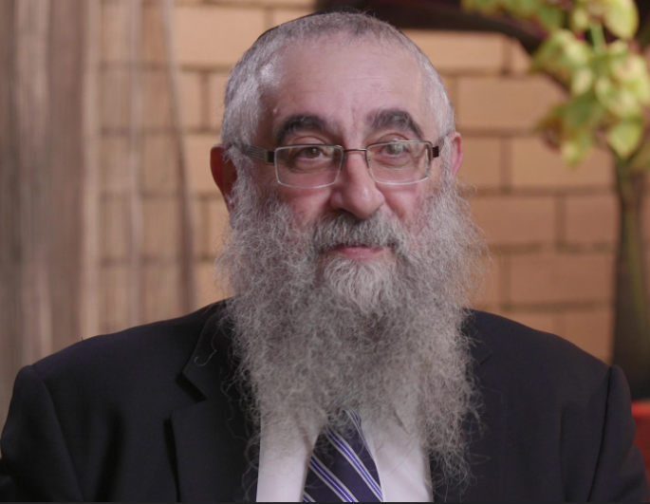

I was born and raised in Melbourne, Australia, where my parents settled after World War Two. My father was a Holocaust survivor from Poland, while my mother emigrated from Egypt, which was then a British protectorate. Although both originally came from religious homes, they were not Torah observant, but they had strong Jewish identities.
In 1966, as my Bar Mitzvah drew near, they moved from West Preston, a predominantly non-Jewish suburb of Melbourne, to the more Jewish East St. Kilda. They did this just so that I could attend the Chabad school there and learn a little about Judaism. However, I took what I learned very seriously and, while this was not their intention, I ultimately became fully religious, as did the rest of my family.
After high school, I was accepted into the dentistry school at Melbourne University, but what I really wanted to do was study Torah at Chabad’s Yeshivah Gedolah. My parents were initially worried that I would squander a great opportunity for a higher education and a lucrative profession, but they agreed to a short deferment, and I got to learn Torah for one more year before going on to university. Incidentally, I never did become a dentist; instead, I became a fundraiser for the Yeshivah Gedolah. I like to joke that I do extractions of a different nature – pulling money out of people instead of teeth.
During the years that followed, I became a true Chabad chasid and I visited New York a number of times to see the [Lubavitcher] Rebbe – I merited four private audiences with him between 1973 and 1980. But the story I’d like to relate here is what happened in 1983 while my wife, Gita, was pregnant with our second child.
Our first child, Yossi, had been delivered by C-section, what we call a Cesarean in Australia. Afterwards, the doctor told us that once you had a Cesarean, every subsequent delivery will have to be by Cesarean, which can only be done a maximum of four or five times.
Naturally, my wife and I were not happy about this news. We sought a second opinion from another obstetrician, who told us that this didn’t necessarily need to be the case. Natural delivery might be possible after all, depending on the circumstances.
When my wife became pregnant for the second time, the pregnancy proceeded normally. However, when she was ten days overdue, the doctor said that this situation could not continue. The baby was getting bigger, which meant that the chances of normal delivery were diminishing by the day. It was a Thursday, and he booked an operating room for a Cesarean on the following Tuesday.
That Thursday night, I called New York and spoke with the Rebbe’s secretary, Rabbi Binyomin Klein. I wanted him to ask the Rebbe two things – should my wife proceed with the Cesarean, and should I proceed with a tonsillectomy to remedy a recurring infection that was not responding to antibiotics.
The next day, Friday, I called Rabbi Klein again numerous times to see if there was an answer from the Rebbe. But the phone was constantly busy. I did not manage to get through until Sunday, when Rabbi Klein informed me that he had an answer from the Rebbe. The Rebbe gave us blessings but he had responded to my two questions in completely different ways. And as he often did, the Rebbe wrote in shorthand so Rabbi Klein needed to explain his words to me.
As far as the tonsillectomy, the Rebbe answered that we should act “according to the advice of the doctor.” As far as the Cesarean, the Rebbe answered, “meanwhile the Nine Days.”
We were about to start the “Nine Days” – the period of mourning for the destruction of Jerusalem which begins on the first day of the Hebrew month of Av, and which culminates on the ninth of Av – known as Tisha B’Av – the terrible date on the Jewish calendar when both the First Temple and Second Temple were destroyed by invaders. Rabbi Klein explained that the Rebbe meant that the “Nine Days” are not a good time for operations, so we should wait until they are over.
I called the doctor on Monday and informed him that I had consulted the Rebbe and he had advised to postpone the Cesarean. Both my wife and I agreed on this. Although we realized that we were putting both my wife’s life and our baby’s life on the line by listening to the Rebbe and not to the doctor, we trusted the Rebbe one hundred percent.
The doctor was very respectful of our decision, but he also said that if the baby goes into distress, it would not be possible to wait until after Tisha B’Av since, in any case, the birth was already almost three weeks overdue.
As it happened, our daughter, Rivki, was born totally naturally on the following Sunday, the seventh of Av, during the “Nine Days.” (In hindsight, I realized that the Rebbe’s words could also be understood as an allusion to this: There was no need for the Cesarean because the baby would be born meanwhile, during the “Nine Days”!)
Afterwards, the doctor said, “I want to tell you something which I didn’t tell you before. When your wife’s labor started last night, I was ninety percent sure we would be doing a Cesarean and I acted accordingly, but somehow things turned around overnight.”
The anesthetist told us something similar. He said our doctor had booked him in for the Cesarean, and then he was amazed to hear that the Cesarean had been canceled. He had never had anything like that happen before.
A few days later, I went to the hospital for my tonsillectomy.
Rivki grew up happy and healthy and is now a Rebbetzin, serving the community of Central Shule Chabad of Melbourne, alongside her husband, Rabbi Shmuel Karnowsky. As for my wife, in the years that followed – thanks to the Rebbe’s blessing – she delivered eight more children, all of them naturally.

Mr. Avrohom Procel serves as executive director of the Rabbinical College of Australia and New Zealand (Yeshivah Gedolah – Melbourne). He was interviewed in July 2016.

Reprinted from the Parshat Matot-Masei 5786 email of The JEM Foundation’s Here’s My Story [with the Lubavitcher Rebbe.]

